Executive summary

Despite efforts to improve early case detection, tuberculosis (TB) disease incidence in Africa remains high. Over 200 million Africans have latent TB infection (LTBI) from which new disease will occur. Scale-up of preventive treatment for LTBI can significantly reduce TB morbidity, mortality and transmission, but is hampered by our poor ability to predict who will progress from LTBI to TB disease in near future. Recent developments in biomarker discovery hold great promise for novel prediction tests with better positive predicting value, that probably detect TB disease in early, asymptomatic stage (incipient TB) and for which WHO defined a Targeted Product Profile (TPP).

Predicting the Future: Incipient TB (PreFIT) is a research and capacity building project funded by the European-Developing Countries Clinical Trials Platform (EDCTP), a mechanism under the EU’s Horizon 2020 research program. It aims to validate ready-to-use candidate assays for incipient TB in populations of intended use across different high-burden settings in Mozambique, South Africa and Uganda. These include a GeneXpert cartridge-based 3-gene signature (Xpert Host Response), C-reactive protein, hemoglobin and markers of iron homeostasis.

PreFIT will establish a diagnostic trial cohort of 4040 highly exposed HIV-negative and positive TB-free contacts followed prospectively for development of culture-confirmed TB disease for 12 months with candidate testing at months 0 and 6 (Figure 1). The assays will be validated for clinical performance to predict TB disease, feasibility and cost when used at point-of-care.
Figure 1. Study flow diagnostic trial

The project will deliver robust estimates of predictive performance for each candidate assay and for various combinations of assays, allowing cost-optimized algorithms to be defined (Figure 2). PreFIT’s results will contribute to WHO endorsement and CE marking of successful candidates meeting the TPP. It in addition aims to strengthen the capacity of the African clinical institutions in the consortium through training, technical assistance and enabling storage of the cohort samples to support future research. To this end it will collaborate with EDCTP’s Networks of Excellence TESA (Southern Africa) and EACCR (Eastern Africa).

Figure 2. Project schematic

The PreFIT consortium (Figure 3), led by the Amsterdam Institute for Global Health and Development, has an excellent track record of working together in research and capacity building consortia, leading expertise in TB diagnostic studies, capacity for large-scale case-contact follow-up studies and, through FIND, a unique network and knowledge regarding diagnostic development and market introduction.

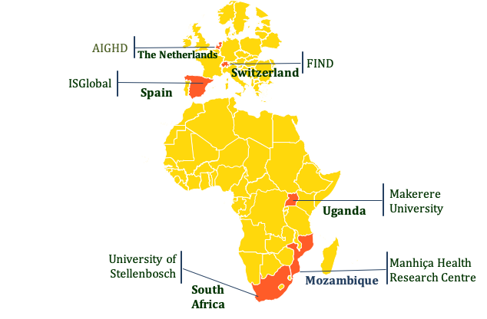
Figure 3. Consortium

The project is structured by 5 work packages, addressing coordination and management (1), the diagnostic evaluation trial (2), assay validation, feasibility, costing and analyses (3), communication, dissemination and uptake (4) and capacity building and networking. It started on 1 February 2020, will take 48 months (figures 2 and 4). External stakeholder involvement plays an important role, through an international advisory board, local community advisory boards, and independent members of its Trial Steering Committee.

Figure 4. Project work packages and timeline

Contact details

Project website:
https://predictingtb.org/

Project coordinator:
Prof. Frank Cobelens
Amsterdam Institute for Global Health and Development (www.aighd.org)
f.cobelens@aighd.org

Project manager:
Mark van Kneglsel
Amsterdam Institute for Global Health and Development (www.aighd.org)
m.vanknegsel@aighd.org

Trial registration:
NCT04825327


The EDCTP2 programme is supported by the European Union’s Horizon 2020 research and innovation programme

